GLOBAL QUEST TECHNOLOGIES



**Soul Society-Online Shopping Website**

Using HTML & CSS

**P.Srithish**

**(GQT-SO173)**

Under the Guidance of Trainer

**Keshava**

(Web Development trainer at GQT)

____________ ____________

Signature of Trainer Signature of CEO(GQT)

# Soul Society – Shopping Website

# Scope of the Document

In the fast-paced digital age, where convenience and accessibility are paramount, the world of shopping has undergone a remarkable transformation. Gone are the days of bustling malls and crowded stores; today, the world shops online. Welcome to a new era of retail, where you can explore an endless array of products from the comfort of your home or anywhere with an internet connection.

Our online shopping platform represents the pinnacle of this retail revolution, seamlessly blending cutting-edge technology with user-friendly design. Developed using the powerful combination of HTML and CSS, our website is your gateway to a world of endless shopping possibilities.

The advantages of online shopping are numerous and compelling. No more battling traffic or waiting in long lines. Say goodbye to the limitations of traditional store hours. With just a few clicks or taps, you can explore a vast selection of products, compare prices, read reviews, and make well-informed decisions.

At our online shopping destination, we're committed to delivering an unparalleled shopping journey:

**User-Friendly Interface:** Our website's intuitive design ensures that you can navigate effortlessly, whether you're a tech-savvy shopper or new to online retail.

**Endless Selection:** We collaborate with an extensive network of sellers to offer you a vast array of products, from fashion and electronics to home decor and more.

**Convenient Features:** Read detailed descriptions and to make informed choices and you can find more number of products. Customize your shopping experience to suit your preferences.

**Responsive Design:** Our website adapts to your device, whether you're browsing on a desktop, tablet, or smartphone, ensuring a seamless shopping experience on any screen size.

**Technologies –** HTML & CSS

**INTRODUCTION:**

**History of HTML**

HTML stands for Hyper Text Markup Language.

* It is used to share the information over the internet.
* HTML id developed by Tim Berner’s Lee in 1991.But officially in 1993.
* The First version of HTML consists of “18 tags”
* HTML follows certain rules and regulations setup by “ISO”.(International Organization for standardization). These set of rules and regulation are present in ‘SGML document’.

**Versions of HTML**

1. HTML-1 version in the year 1993.
2. Html-2 version in the year 1995.
3. HTML-3.02 version in the year 1997.
4. HTML-4.1 version in the year 1999.
5. HTML-5 version in the year 2014

**Features of HTML**

* It is easy to Learn.
* It is a tag based language.
* HTML is supported by multiple browsers.
* First web browser is Netscape navigation which was developed by the “Mosiac”.
* It is a portable language.
* WORA (write once run anywhere).

**Limitation of HTML**

* HTML has less designing capabilities.
* It is dependent on other technology such as CSS in order to develop well designed Web pages.
* HTML has no programming capabilities.
* Using HTML and CSS we can develop only static Web page.
* In order to write the HTML code required an editor such as VS Code, Notepad, Eclipse.
* In order to execute the HTML code we required Web browsers.Like Chrome, Firefox, edge, Opera Safari .

**CSS**

* CSS stands for Cascading Style Sheets.
* It was developed by W3C to add stylings to the HTML elements.
* W3C stands for World Wide Web.com

**Versions of CSS:**

1. CSS-1 (level-1) in the year 1996.
2. CSS-2 (level-2) in the year 1998.
3. CSS-3 (level-3) in the year 1999.

**Why do we required CSS ?**

* Since HTML has less designing capabilities we cannot create well designed or most appealing Websites.
* Using HTML we cannot add style, animation and transitions to the Webpage.
* Therefore we require CSS to create well designed Webpages.

**Advantages of CSS**

* It allows to add styles, animation and variouses effects to the Webpage.
* It allows us to develop the Webpage rapidly. It is also know as RAD ( rapid application Developer).
* It allows us to separate from formatting develop page to the presentation of Webpage.
* It allows to create well designed Websites.

**Limitations of CSS**

* Using CSS we can perform static styles for the Webpages.
* In order to create dynamic styling for the Websites. We must make use of scripting language such as JavaScript and Libraries of JavaScript.

**Types of CSS:**

1. Inline CSS
2. Internal CSS
3. External CSS
4. Default Browser CSS

**Inline CSS:** Defining all the CSS properties within the style attribute inside the opening of the tag is referred to as Inline CSS.

**Internal CSS:** Defining all the CSS properties within <style> inside the HTML document is referred to as Internal CSS.

**External CSS:** Defining all the CSS properties within as external Script or File with an extension CSS is referred to as External CSS.

* In order to link external CSS file within the HTML document we must use of <link>.
* The value for the ‘ref’ attribute should be ‘stylesheet’.

**Home Page :**

**/*index.css*/**

!DOCTYPE html>

<html lang="en">

<head>

<meta charset="UTF-8">

<meta name="viewport" content="width=device-width, initial-scale=1.0">

<title>SoulSociety</title>

<link rel="icon" href="logo.png">

<link rel="stylesheet" href="index.css">

</head>

<body>

<div>

<div id="one">

<a href="index.html`"><img src="logo.png" style="height: 50px;width: 50px;margin-top: 15px;margin-left: 50px;"></a>

<div style="height: 50px;width: 400px; margin-top: 26px;margin-left: 10px;"><h2 style="font-family:HelveticaNeueLTPro-Roman,HelveticaNeue-Roman,Helvetica Neue Roman,Helvetica Neue,Helvetica,Arial,Lucida Grande,sans-serif;">SoulSociety</h2></div>

<div style="margin-left: -9%;">

<nav id="nav1">

<a href="index.html">HOME</a>

<a href="about.html">ABOUT</a>

<a href="ques.html">FAQ's</a>

<a href="support.html">SUPPORT</a>

</nav>

</div>

<div id="one2">

<a href="#"> <img src="search logo.png"></a>

<a href="wishlist.html"> <img src="wishlogo.png"></a>

<a href="cart.html"> <img src="cartlogo.png"></a>

<a href="accont.html" target="_blank"><img src="accntlogo.png"></a>

</div>

</div>

<br><br><br><br>

<div id="two" >

<marquee style="word-spacing: 5px;">Get FLAT-25% OFF On First-Order with Coupon : FSOUL. Terms & Conditions may Apply </marquee>

</div>

<div id="three">

<div class="th1">

<br><br><br><br><br><br>

<h3 style="color: white ;background-color: black;display: inline;padding: 5px;margin-left: 9%;">NEW ARRIVAL FOR MEN</h3>

<br><br>

<h2 style="color: BLACK;font-size: 30px;margin-left: 2%; ">OVERSIZED GRAPHIC</h2><br>

<h2 style="color: BLACK;font-size: 20px;margin-left: 15%; font-weight: 400;">PRINTED T-SHIRTS</h2><br><br>

<button style="width: 120px;height: 40px;border-radius: 30px;background-color: black;color: white; margin-left: 17%;"class="newarr"onclick="location.href=('men.html')">SHOP NOW</button>

</div>

<div class="th2"><img src="newarrival.jpg"style="height:100%"></div>

</div>

<div id="four">

<div class="th3"><img src="girls new.webp"style="height:100%">

</diV>

<div class="th4" >

<br><br><br><br><br><br>

<h3 style="color: white ;background-color: black;display: inline;padding: 5px;margin-left: 8%;">NEW ARRIVAL FOR WOMEN</h3>

<br><br>

<h2 style="color: BLACK;font-size: 30px;margin-left: 2%; ">OVERSIZED GRAPHIC</h2>

<br>

<h2 style="color: BLACK;font-size: 20px;margin-left: 15%; font-weight: 400;">PRINTED T-SHIRTS</h2>

<br><br>

<button style="width: 120px;height: 40px;border-radius: 30px;background-color: black;color: white; margin-left: 19%;"class="newarr"onclick="location.href=('women.html')">SHOP NOW</button>

</div>

</div><br><br>

<div class="five">

<div class="five1"style="margin-top:50px">

<a href="men.html"><img src="men.webp" style="width: 100%;height:290px"> </a>

<br>

<h2 style="text-align: center;padding: 10px;">For Mens</h2>

</div>

<div class="five2"style="margin-top:50px">

<a href="women.html"> <img src="women.webp" style="width: 100%;height:290px"> </a>

<br><h2 style="text-align: center;padding: 10px;">For Womens</h2>

</div>

<div class="five3"style="margin-top:50px">

<a href="kids.html"><img src="kids.webp" style="width: 100%;height:290px"></a>

<br><h2 style="text-align: center;padding: 10px;">For Kids</h2> </div>

<div class="five4"style="margin-top:50px">

<a href="access.html"><img src="audio.webp" style="width: 100%;height:290px"> </a>

<br><h2 style="text-align: center;padding: 10px;">For Accessories</h2>

</div>

</div>

<br>

<div id="about4">

<br><h3 style="font-size: 40px;text-align: center;">Top Categories</h3>

<br><br>

<div style="display: flex;justify-content: space-around;">

<img style="width:20%;height:100%" src="winterwear.webp">

<img style="width:20%;height:100%" src="oversize.webp">

<img style="width:20%;height:100%" src="mangaS.webp">

<img style="width:20%;height:100%" src="stickers.webp">

</div>

</div>

<div id="six">

<img src="Black & White Minimalist Business Logo.png" style="height: 200px;width: 200px;">

<br>

<div id="footer">

<div class="six1">

<h3 style="color:aqua">Customer Services</h2>

<br>

<a href="">Contact Us</a><br><br>

<a href="">Track Order</a><br><br>

<a href="">Return Order</a><br><br>

<a href="">Cancel order</a>

</div>

<div class="six1">

<h3 style="color:aqua">Company</h2>

<br>

<a href="about.html">About Us</a><br><br>

<a href="">We are Hiring</a><br><br>

<a href="tc.html">Terms & Conditions</a><br><br>

<a href="priv.html">Privacy Policy</a><br><br>

<a href="blog.html">Blog</a>

</div>

<div class="six1">

<h3 style="color:aqua">Connect With Us</h2>

<br>

<a href=""><img src="facebook.svg"></a> Facebook<br><br>

<a href=""><img src="instagram.svg"></a> Instagram<br><br>

<a href=""><img src="twitter.svg"></a> Twitter<br><br>

</div>

<div class="six1">

<h3 style="color:aqua">Keep Up to Date</h2>

<br>

<form action="">

<input style="height: 30px;" type="email"placeholder="Enter email"><input style="height: 30px;" type="submit" value="Subscribe">

</form>

<br><br>

<a href=""><img style="height: 50px;width: 150px;" src="downloadApple.svg"></a>

<br>

<a href=""><img style="height: 50px;width: 150px;" src="downloadGoogle.svg" ></a>

</div>

</div>

</div>

</div>

</body>

</html>

**/*index.css*/**

*{

margin:0px;

font-family: sans-serif;

box-sizing: border-box;

}

#one{

width: 100%;

height: 80px;

box-shadow: 0px 2px 4px;

position: fixed;

background-color : white;

z-index: 9999;

display: flex;

}

#nav1{

margin-top:35px;

font-size: 16px;

font-weight: 600;

color: black;

font-family:HelveticaNeueLTPro-Roman,HelveticaNeue-Roman,Helvetica Neue Roman,Helvetica Neue,Helvetica,Arial,Lucida Grande,sans-serif;

#nav1 a{

padding-right: 15px;

padding-left: 15px;

text-decoration: none;

padding-top: 10px;

padding-bottom: 10px;

color: black;

}

#nav1 a:hover{

background-color: rgb(234, 234, 234);

}

#nav a:visited{

color: black;

}

#one2{

width:300px;

height: 30px;

margin-top: 28px;

margin-left: 25%;

display: flex;

justify-content: space-around;

}

#one2 img{

width: 30px;

height: 25px;

}

#one2 img:hover{

outline: 2px solid black;

outline-offset: 3px;

transition-delay: 0.1;

}

#two{

padding-top: 10px;

height:30px;

background-color: black;

color: white;

}

#three{

height: 400px;

background-color: beige;

display: flex;

}

.th1{

width:35%;

margin-left:13%;

}

.th2{

width:35%;

margin-left:10%;

}

#four{

height: 400px;

background-color:bisque;

display: flex;

}

.th3{

width:35%;

margin-left:15%;

}

.th4{

width:35%;

}

.newarr:hover{

outline: 2px solid black;

outline-offset: 5px;

}

.five{

background-color:white;

width: 100%;

height:450px;

display: flex;

justify-content: space-around;

position: relative;

}

.five1,.five2,.five3,.five4{

width: 16%;

height: 350px;

background-color: black;

color:white;

font-size: 17px;

}

.five1:hover,.five2:hover,.five3:hover,.five4:hover{

background-color: white;

border:2px solid black;

color:black;

box-shadow: 2px 2px 6px black ;

}

#about4{

width: 100%;

height: 500px;

background-color: #F4F4F2;

}

#six{

height:400px;

background-color: black;display: flex;

}

#footer{

width: 80%;

height: 250px;

margin-left: 0%;

display: flex;

justify-content: space-between;

color:white;

}

.six1{

margin-top: 0px;

width:20%;

height:100%;

margin-top: 100px;

text-align: left;

}

.six1 a{

text-decoration: none;

color: white;

}

.six1 a:hover{

text-decoration: underline;

}

/*support*/

#support{

width: 100%;

height: 700px;

display: flex;

}

#support1{

width: 45%;

height: 500px;

position: absolute;

margin-left: 5%;

margin-top: 100px;

}

#support2{

margin-left: 65%;

width: 20%;

height: 500px;

position: absolute;

margin-top: 100px;

}

/*ques.html*/

#qbutton{

margin-left: 43%;

width: 12%;

height: 50px;

background-color: black;

border-radius: 30px;

color: white;

font-weight: 600;

display: flex;

align-items: center;

justify-content: center;}

#qbutton:hover{

outline: 2px solid black;

outline-offset:5px ;

}

.last{

width: 80%;

margin-left:10%;

padding: 15px 0;

padding-top: 25px;

cursor: pointer;

display: flex;

font-size: 14px;

color: black;

font-weight: 500;

border-bottom: 1px solid grey;

}

.six1 img:hover {

border: 2px solid white;

}

/*about*/

#about1{

width:80%;

margin-left: 10%;

height: 650px;

display: flex;

position: relative;

}

#about2{

width: 30%;

height:70%;

margin-left: 5%;

position: absolute;

top: 15%;

}

#about3{

width:55%;

height:50%;

position: absolute;

margin-left: 40%;

top:30%;

padding-right: 50px;

padding-left: 50px;

padding-top: 50px;

background-color: #F4F9F9;

}

#about5{

width: 80%;

height: 410px;

margin-left: 10%;

background-color: #F4F9F9;

}

/*men*/

.men1{

width: 100%;

height: 400px;

display: flex;

justify-content: space-around;

}

.men2{

width:17%;

height: 100%;

background-color: white;

box-shadow: 3px 3px 6px black ;

border-radius: 20px;

}

.men2 button:hover{

outline: 2px solid black;

outline-offset: 2px;

}

.move:hover{

border: 2px white solid;

}

.move a:hover{

color: black;

}

.tc p{

font-size: 16px;

line-height: 26px;

}

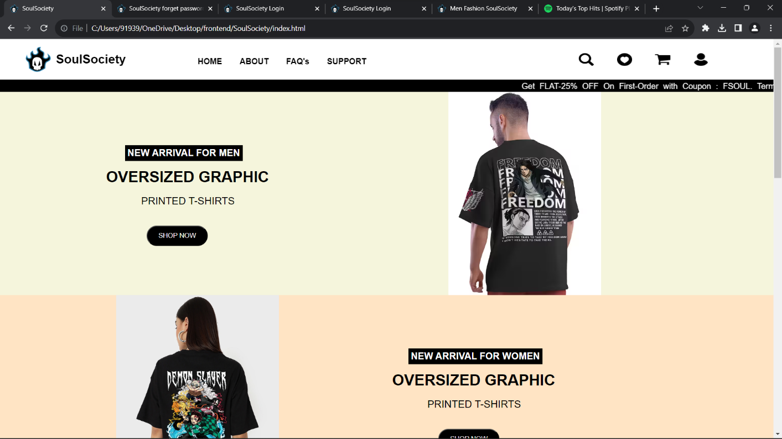

**Hompage-ScreenShot:1**

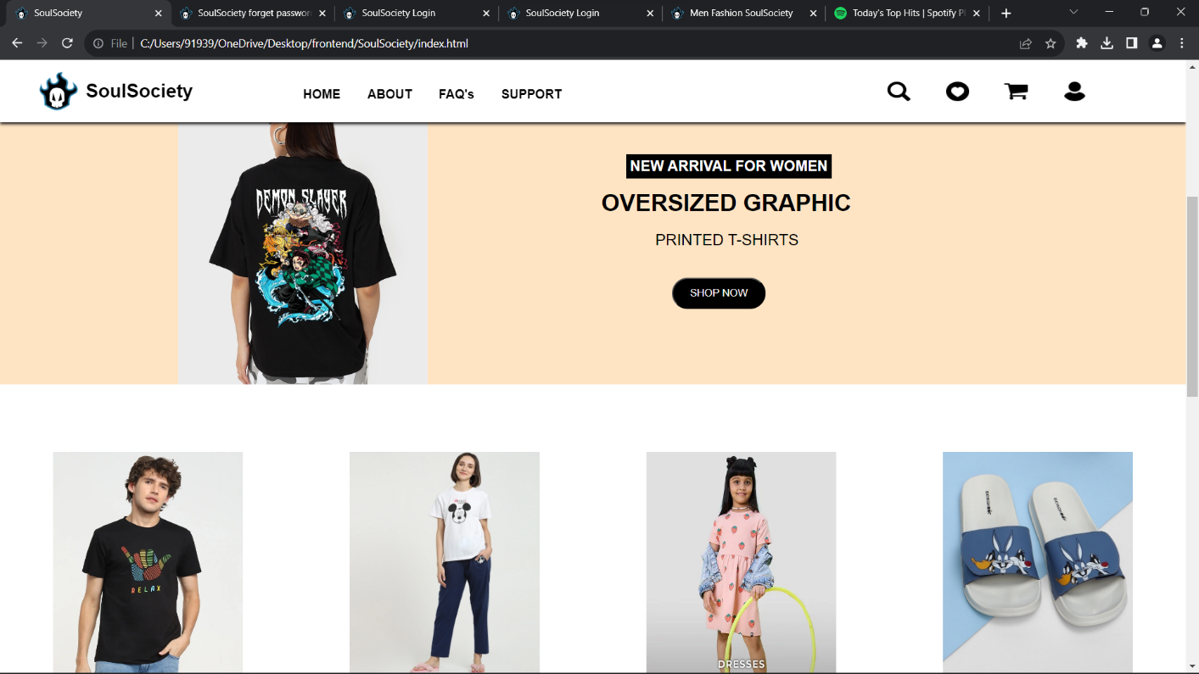

**Hompage-ScreenShot:2**

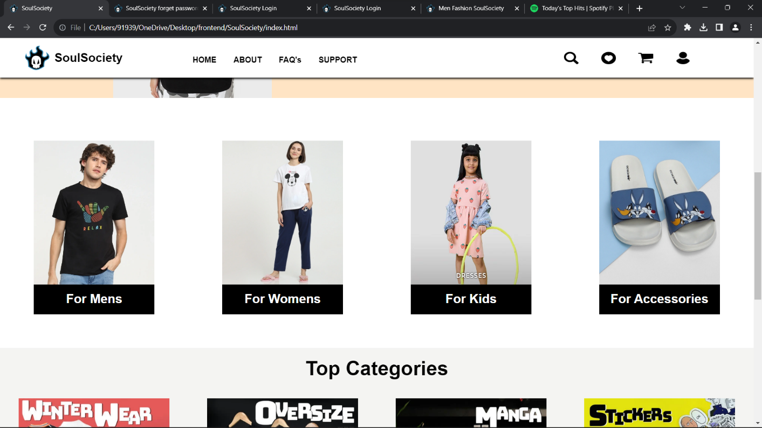

**Hompage-ScreenShot:3**

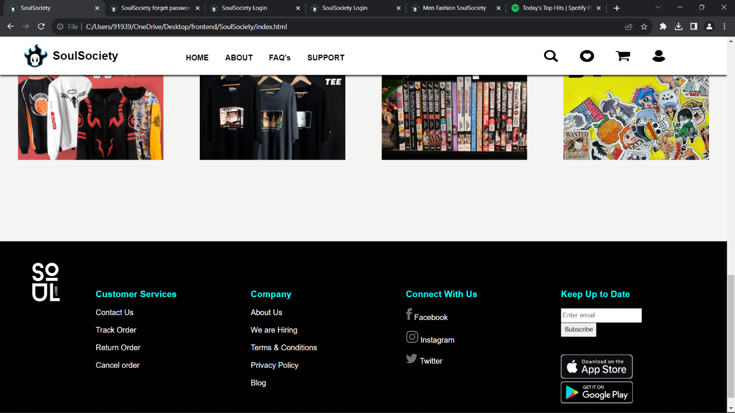

**Hompage-ScreenShot:4**

**About Page :**

**/*about.html*/**

<!DOCTYPE html>

<html lang="en">

<head>

<meta charset="UTF-8">

<meta name="viewport" content="width=device-width, initial-scale=1.0">

<title>About SoulSociety</title>

<link rel="icon" href="logo.png">

<link rel="stylesheet" href="index.css">

</head>

<body style="background-color:#D2E9E9;">

<div>

<div id="one">

<a href="index.html"><img src="logo.png" style="height: 50px;width: 50px;margin-top: 15px;margin-left: 50px;"></a>

<div style="height: 50px;width: 400px; margin-top: 26px;margin-left: 10px;"><h2 style="font-family:HelveticaNeueLTPro-Roman,HelveticaNeue-Roman,Helvetica Neue Roman,Helvetica Neue,Helvetica,Arial,Lucida Grande,sans-serif;">SoulSociety</h2></div>

<div style="margin-left: -9%;">

<nav id="nav1">

<a href="index.html">HOME</a>

<a href="about.html">ABOUT</a>

<a href="ques.html">FAQ's</a>

<a href="support.html">SUPPORT</a>

</nav>

</div>

<div id="one2">

<a href="#"> <img src="search logo.png"></a>

<a href="wishlist.html"> <img src="wishlogo.png"></a>

<a href="cart.html"> <img src="cartlogo.png"></a>

<a href="accont.html" target="_blank"><img src="accntlogo.png"></a>

</div>

</div>

<br><br><br>

<div id="about1">

<div id="about2">

<h3 style="color: black;font-weight: 400;font-size: 42px;"><span style="border-bottom: rgb(247, 54, 96) 3px solid;">Ou</span>r Story</h3>

<br><br><br>

<img src="logo.png" style="width: 60%;margin-left: 20%;width: 60%;">

</div>

<div id="about3">

<h3 style="font-size: 27px;">Soul Society</h3>

<br>

<p style="line-height: 29px;">The Soul Society was born out of the idea of loving what you do - “following your soul”. Our philosophy is that life is short. Don’t spend it doing something you don’t like. There are too many Monday mornings, and you can’t go dreading every single one of them.</p>

<br><br>

<h3 style="font-style: oblique;font-family: cursive;">“Beauty awakens the soul to act.” ~Dante Alighieri</h3>

</div>

</div>

<div id="about5">

<br>

<br><h3 style="font-size: 40px;text-align: center;">Whats makes us Unique</h3>

<br>

<hr style="background-color: grey;"><br><br>

<div style="display: flex;justify-content: space-around;">

<div style="width:25%;height:150px;justify-items: center;background-color: #F4F9F9; padding-top: 30px;" >

<h3 style="font-size: 28px;text-align: center;">Innovative design</h3>

<br><br>

<p style="text-align: center;font-weight:bold">Creating designs that are an extension of you.</p>

</div>

<div style="width:30%;height:150px;text-align: center;padding-top: 30px;" >

<h3 style="font-size: 28px;text-align: center;">Direct to consumer model</h3>

<br><br>

<p style="text-align: center;font-weight:bold">Bringing accessibility and value to everyday <br>fashion.</p>

</div>

<div style="width:25%;height:150px;text-align: center;padding-top: 30px;" >

<h3 style="font-size: 28px;text-align: center;">Homegrown</h3>

<br><br>

<p style="text-align: center;font-weight:bold">Imagined in India, Made in India.</p>

</div>

</div>

</div>

<br><br><br><br><br>

<div id="six">

<img src="Black & White Minimalist Business Logo.png" style="height: 200px;width: 200px;">

<br>

<div id="footer">

<div class="six1">

<h3 style="color:aqua">Customer Services</h2>

<br>

<a href="support.html">Contact Us</a><br><br>

<a href="">Track Order</a><br><br>

<a href="">Return Order</a><br><br>

<a href="">Cancel order</a>

</div>

<div class="six1">

<h3 style="color:aqua">Company</h2>

<br>

<a href="about.html">About Us</a><br><br>

<a href="">We are Hiring</a><br><br>

<a href="tc.html">Terms & Conditions</a><br><br>

<a href="priv.html">Privacy Policy</a><br><br>

<a href="blog.html">Blog</a>

</div>

<div class="six1">

<h3 style="color:aqua">Connect With Us</h2>

<br>

<a href=""><img src="facebook.svg"></a> Facebook<br><br>

<a href=""><img src="instagram.svg"></a> Instagram<br><br>

<a href=""><img src="twitter.svg"></a> Twitter<br><br>

</div>

<div class="six1">

<h3 style="color:aqua">Keep Up to Date</h2>

<br>

<form action="">

<input style="height: 30px;" type="email"placeholder="Enter email"><input style="height: 30px;" type="submit" value="Subscribe">

</form>

<br><br>

<a href=""><img style="height: 50px;width: 150px;" src="downloadApple.svg" ></a><br>

<a href=""><img style="height: 50px;width: 150px;" src="downloadGoogle.svg" ></a>

</div>

</div>

</div>

</div>

</body>

</html>

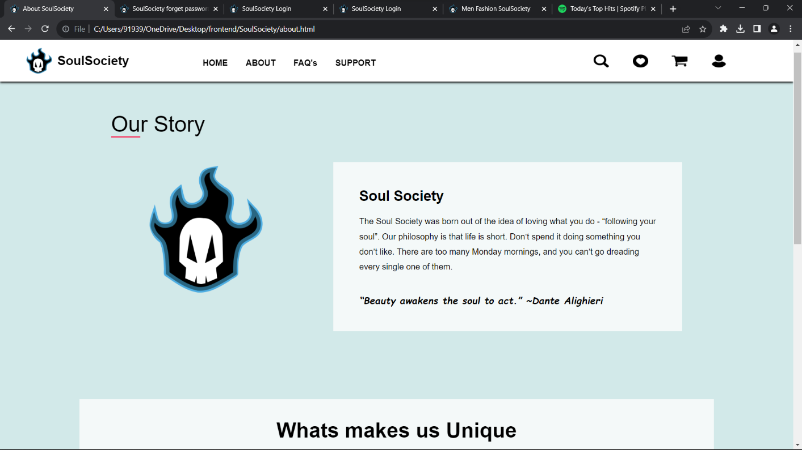

**Aboutpage-ScreenShot:1**

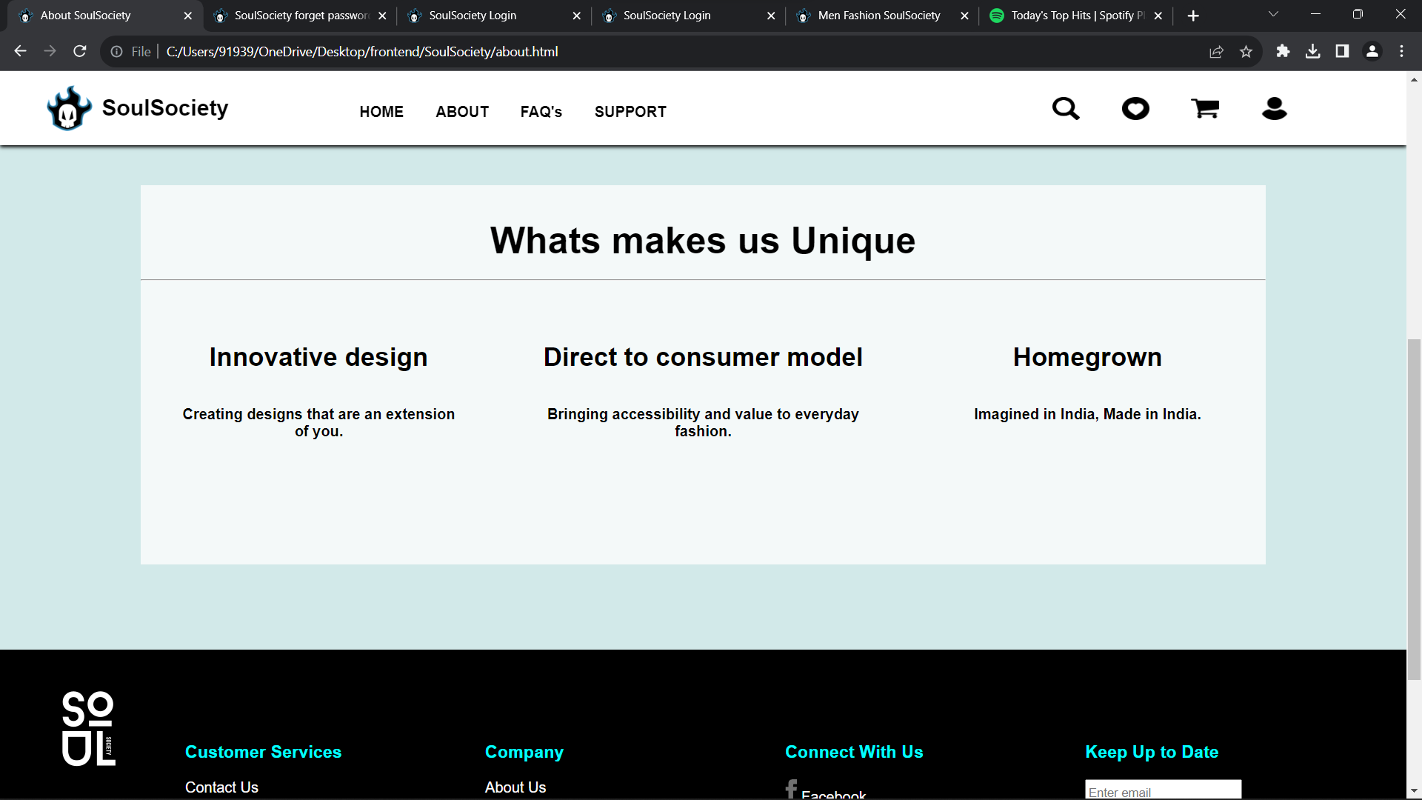

**Aboutpage-ScreenShot:2**

**FAQ’S Page :**

**/*ques.html*/**

<!DOCTYPE html>

<html lang="en">

<head>

<meta charset="UTF-8">

<meta name="viewport" content="width=device-width, initial-scale=1.0">

<title>SoulSociety</title>

<link rel="icon" href="logo.png">

<link rel="stylesheet" href="index.css">

</head>

<body>

<div>

<div id="one">

<a href="index.html"><img src="logo.png" style="height: 50px;width: 50px;margin-top: 15px;margin-left: 50px;"></a>

<div style="height: 50px;width: 400px; margin-top: 26px;margin-left: 10px;"><h2 style="font-family:HelveticaNeueLTPro-Roman,HelveticaNeue-Roman,Helvetica Neue Roman,Helvetica Neue,Helvetica,Arial,Lucida Grande,sans-serif;">SoulSociety</h2></div>

<div style="margin-left: -9%;">

<nav id="nav1">

<a href="index.html">HOME</a>

<a href="about.html">ABOUT</a>

<a href="ques.html">FAQ's</a>

<a href="support.html">SUPPORT</a>

</nav>

</div>

<div id="one2">

<a href="#"> <img src="search logo.png"></a>

<a href="wishlist.html"> <img src="wishlogo.png"></a>

<a href="cart.html"> <img src="cartlogo.png"></a>

<a href="accont.html" target="_blank"><img src="accntlogo.png"></a>

</div>

</div>

<br><br><br><br><br><br><br>

<h2 style="text-align: center;font-size: 40px;">Manage Your Orders Easily</h2><br>

<h3 style="text-align: center;font-size: 22px;font-weight: 300;">Track, Return/ Exchange, or Cancel your orders hassle-free.</h3><br>

<div id="qbutton">

<h3><a href="#" style="text-decoration: none;color: white;">My Orders</a></h3>

</div>

<br><br>

<hr style="background-color: solid 2px #ffe9e3">

<h2 style="text-align: center;font-size: 40px;padding-left: 10px;background-color: #e3f6f5;font-family: cursive;">FAQ</h2><hr>

<br>

<div>

<h3 style="margin-left:8%">Before Order</h3>

<div class="last">

<a href=""> <img src="plus.svg"></a>

<p style="margin-left: 10px;"> What are “Soul Society Wallet” points? How do I use/earn them?</p>

</div>

<div class="last">

<a href=""> <img src="plus.svg"></a>

<p style="margin-left: 10px;"> Do I have to pay any shipping charges?</p>

</div>

<div class="last">

<a href=""> <img src="plus.svg"></a>

<p style="margin-left: 10px;"> Why is there additional COD charges?</p>

</div>

<div class="last">

<a href=""> <img src="plus.svg"></a>

<p style="margin-left: 10px;">Why does it charge me Rs. 1 for order where I am paying via my wallet points /coupons?</p>

</div>

<br><br>

<h3 style="margin-left:8%">During Order</h3>

<div class="last">

<a href=""> <img src="plus.svg"></a>

<p style="margin-left: 10px;"> What’s Pre-Order & how does it work?</p>

</div>

<div class="last">

<a href=""> <img src="plus.svg"></a>

<p style="margin-left: 10px;"> What should I do if I have an issue with payment while placing order?</p>

</div>

<br><br>

<h3 style="margin-left:8%">After Order</h3>

<div class="last">

<a href=""> <img src="plus.svg"></a>

<p style="margin-left: 10px;"> How do I cancel/ modify my order?</p>

</div>

<div class="last">

<a href=""> <img src="plus.svg"></a>

<p style="margin-left: 10px;"> How do I apply for return/ exchange of my product(s)?</p>

</div>

<div class="last">

<a href=""> <img src="plus.svg"></a>

<p style="margin-left: 10px;"> Why was my submitted review not approved?</p>

</div>

<div class="last">

<a href=""> <img src="plus.svg"></a>

<p style="margin-left: 10px;"> The delivery tracking shows that the order has been delivered but I have not received it.</p>

</div>

<br>

<p style="margin-left: 10%;">For any other query just drop us a mail at care@SoulSociety.xyz and our team will get in touch with you within 1-3 business days (most probably within hours).</p>

<br><br><br>

<h3 style="margin-left: 7%;font-weight: 600;text-decoration-line: underline;font-size: 20px;">Corporate Address :</h3>

<br>

<p style="margin-left: 7%;font-size: 14px;font-style: italic;">

Soul Society Pvt. Ltd.<br>

Lorem, ipsum dolor,<br>

3rd Floor, xyz-111,<br>

Next to Flyover, Main Road,<br>

Bangalore, Karnatakaa, 560060

</p>

<br>

<a style="margin-left: 7%;font-size: 14px;text-decoration: none;margin-top: 30px;">Care@SoulSociety.xyz</a>

<p style="margin-left: 7%;font-size: 14px;margin-top: 0px;">+91 9999999999</p>

</div>

<div id="six" style="margin-top: 50px;">

<img src="Black & White Minimalist Business Logo.png" style="height: 200px;width: 200px;">

<br>

<div id="footer">

<div class="six1">

<h3 style="color:aqua">Customer Services</h2>

<br>

<a href="support.html">Contact Us</a><br><br>

<a href="">Track Order</a><br><br>

<a href="">Return Order</a><br><br>

<a href="">Cancel order</a>

</div>

<div class="six1">

<h3 style="color:aqua">Company</h2>

<br>

<a href="about.html">About Us</a><br><br>

<a href="">We are Hiring</a><br><br>

<a href="tc.html">Terms & Conditions</a><br><br>

<a href="priv.html">Privacy Policy</a><br><br>

<a href="blog.html">Blog</a>

</div>

<div class="six1">

<h3 style="color:aqua">Connect With Us</h2>

<br>

<a href=""><img src="facebook.svg"></a> Facebook<br><br>

<a href=""><img src="instagram.svg"></a> Instagram<br><br>

<a href=""><img src="twitter.svg"></a> Twitter<br><br>

</div>

<div class="six1">

<h3 style="color:aqua">Keep Up to Date</h2>

<br>

<form action="">

<input style="height: 30px;" type="email"placeholder="Enter email"><input style="height: 30px;" type="submit" value="Subscribe">

</form>

<br><br>

<a href=""><img style="height: 50px;width: 150px;" src="downloadApple.svg" ></a><br>

<a href=""><img style="height: 50px;width: 150px;" src="downloadGoogle.svg" ></a>

</div>

</div>

</div>

</div>

</body>

</html>

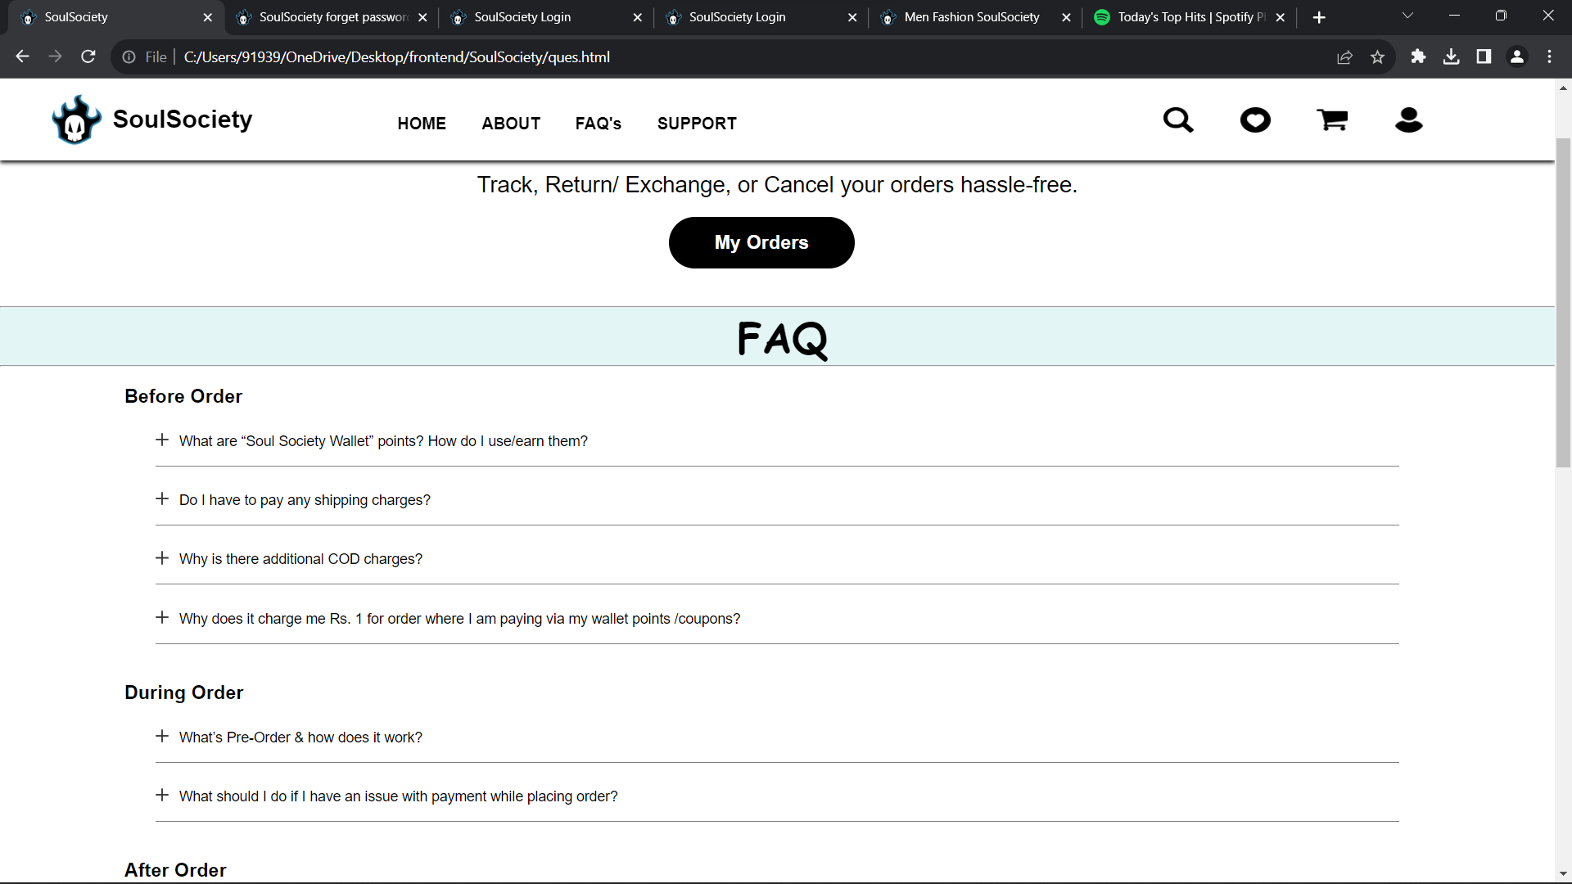

**FAQ’Spage-ScreenShot:1**

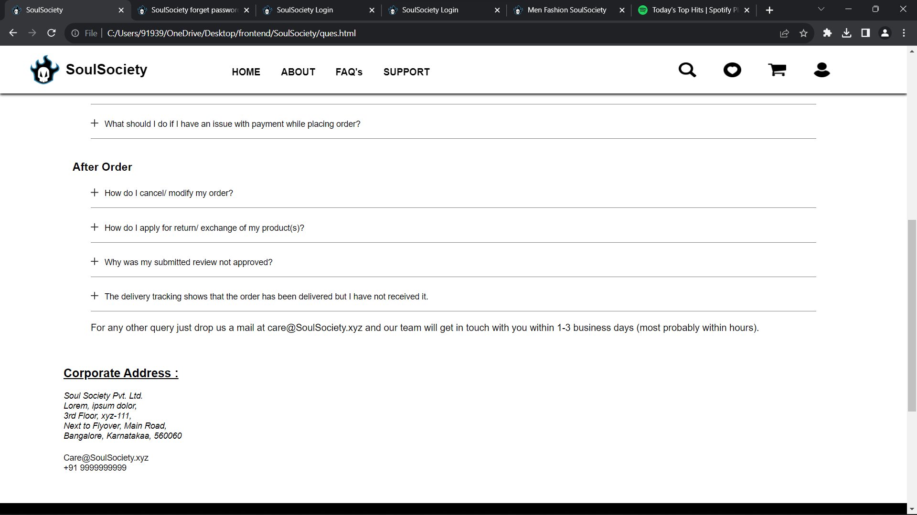

**FAQ’Spage-ScreenShot:2**

**Login Page :**

**/*account.html*/**

<!DOCTYPE html>

<html lang="en">

<head>

<meta charset="UTF-8">

<meta name="viewport" content="width=device-width, initial-scale=1.0">

<title>SoulSociety Login</title>

<link rel="icon" href="logo.png">

<link rel="stylesheet" href="index.css">

</head>

<body>

<h1 align ="center" style="font-family: cursive;background-color: aqua;"><img src="logo.png" style="width:5%;height:40px;margin-top:10px;padding-right: 10px;">Soul Society</h1>

<hr HEIGHT="15px">

<br><br><br>

<div style="width:30%;height:300px; margin-top:7%;margin-bottom:2%;margin-left:33%;background-color: black; border-radius: 10px;">

<form action="index.html">

<div style="margin-top: 10%; ">

<h1 align="center"style="padding-top:10px"> <span style="color: white;">Login to </span> <span style="color:aqua"><b>Soul Society</b></span></h1>

</div>

<hr height="50px">

<div style="margin-top: 10%; margin-left:15%;">

<input style="width:70%;height:30px;border-radius: 5px;" required type="text" placeholder="Email address or Phone number"><br><br>

<input style="width:70%;height:30px;border-radius: 5px;" required type="password" placeholder="password"><br><br>

<a href="forget.html" style="text-decoration: none;color: aqua;font-size: large;">forget password?</a>&nbsp;&nbsp;&nbsp;&nbsp;

<a href="signup.html" style="text-decoration: none;color: aqua; font-size: large;">signup </a><br><br>

<input style="color:rgb(6, 6, 6); margin-left:60%; width:70px; height: 30px;" type="submit" value="submit">

</div>

</form>

</div>

<br><br><br>

<div id="six" style="margin-top: 150px;">

<img src="Black & White Minimalist Business Logo.png" style="height: 200px;width: 200px;">

<br>

<div id="footer">

<div class="six1">

<h3 style="color:aqua">Customer Services</h2>

<br>

<a href="support.html">Contact Us</a><br><br>

<a href="">Track Order</a><br><br>

<a href="">Return Order</a><br><br>

<a href="">Cancel order</a>

</div>

<div class="six1">

<h3 style="color:aqua">Company</h2>

<br>

<a href="about.html">About Us</a><br><br>

<a href="">We are Hiring</a><br><br>

<a href="tc.html">Terms & Conditions</a><br><br>

<a href="priv.html">Privacy Policy</a><br><br>

<a href="blog.html">Blog</a>

</div>

<div class="six1">

<h3 style="color:aqua">Connect With Us</h2>

<br>

<a href=""><img src="facebook.svg"></a> Facebook<br><br>

<a href=""><img src="instagram.svg"></a> Instagram<br><br>

<a href=""><img src="twitter.svg"></a> Twitter<br><br>

</div>

<div class="six1">

<h3 style="color:aqua">Keep Up to Date</h2>

<br>

<form action="">

<input style="height: 30px;" type="email"placeholder="Enter email"><input style="height: 30px;" type="submit" value="Subscribe">

</form>

<br><br>

<a href=""><img style="height: 50px;width: 150px;" src="downloadApple.svg" ></a><br>

<a href=""><img style="height: 50px;width: 150px;" src="downloadGoogle.svg" ></a>

</div>

</div>

</div>

</body>

</html>

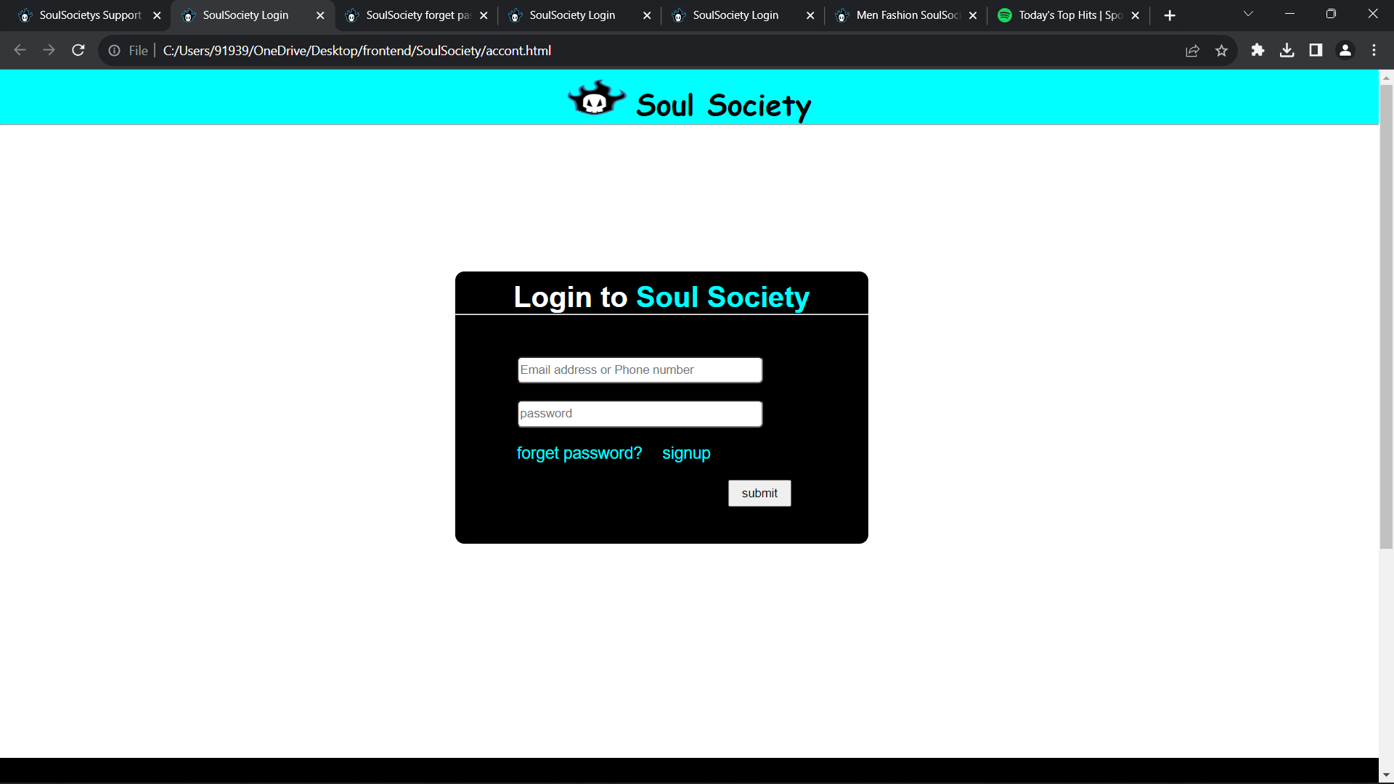

**LoginPage-ScreenShot-1**

**Sign Up Page :**

**/*signup.html*/**

<!DOCTYPE html>

<html lang="en">

<head>

<meta charset="UTF-8">

<meta name="viewport" content="width=device-width, initial-scale=1.0">

<title>SoulSociety signup page</title>

<link rel="icon" href="logo.png">

<link rel="stylesheet" href="index.css">

</head>

<body style="background-color: black;">

<h1 align ="center" style="background-color: aqua;font-family: cursive ;"><img src="logo.png" style="width:5%;height:40px;margin-top:10px;padding-right: 10px;">Soul Society</h1>

<hr HEIGHT="10px">

<div style="width:50%;height:450px;margin-top:8%;margin-bottom:5%;margin-left:25%;margin-left:25%;background-color: rgb(255, 255, 255);border-radius:10px;">

<div style="margin-top: 10%; ">

<h1 align="center">Sign up to <span style="color:aqua"><b>Soul Society</b></span></h1>

</div>

<hr height="50px">

<div style="margin-top: 10%; margin-left:10%;">

<form action="accont.html">

<input required style="width:25%;height:30px;border-radius: 5px;"type="text" placeholder="First Name"><br><br>

<input required style="width:80%;height:30px;border-radius: 5px;"type="text" placeholder="Mobile Number or Email"><br><br>

<input required style="width:80%;height:30px;border-radius: 5px;"type="password" placeholder="New password"><br><br>

<label for="dob"><b>Date of Birth</b></label>&nbsp;&nbsp;&nbsp;&nbsp;&nbsp;&nbsp;

<input required id="dob" type="date"><br><br>

<label for="gen" style="font-weight: bold;">Gender</label><br><br>

<input type="radio" name="gen" value="male">Male

<input type="radio" name="gen" value="female">Female

<input type="radio" name="gen" value="Custom">Custom

<br><br>

<center>

<input style="color:aqua;font-weight: 600; width:70px; height: 30px;" type="submit" value="submit"></center>

</div>

<div style="margin-left: 45%; margin-top:-290px;">

<input style="width:50%;height:30px;border-radius: 5px;"type="text" placeholder="Last Name">

</div>

</div>

</form>

</body>

</html>

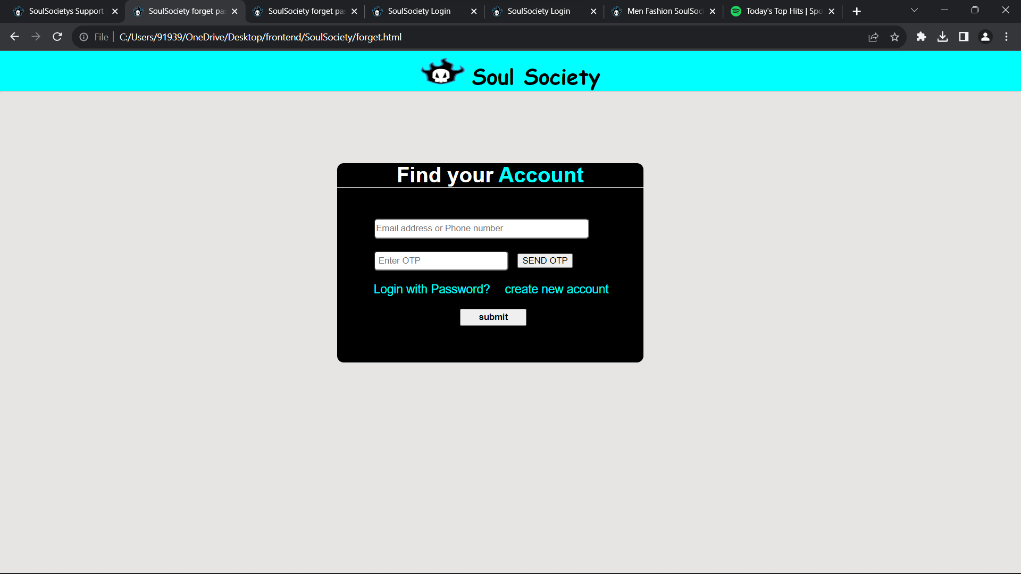

**SignUp-ScreenShot:1**

**Support page:**

**/*support.htm*/**

<!DOCTYPE html>

<html lang="en">

<head>

<meta charset="UTF-8">

<meta name="viewport" content="width=device-width, initial-scale=1.0">

<title>SoulSociety signup page</title>

<link rel="icon" href="logo.png">

<link rel="stylesheet" href="index.css">

</head>

<body style="background-color: black;">

<h1 align ="center" style="background-color: aqua;font-family: cursive ;"><img src="logo.png" style="width:5%;height:40px;margin-top:10px;padding-right: 10px;">Soul Society</h1>

<hr HEIGHT="10px">

<div style="width:50%;height:450px;margin-top:8%;margin-bottom:5%;margin-left:25%;margin-left:25%;background-color: rgb(255, 255, 255);border-radius:10px;">

<div style="margin-top: 10%; ">

<h1 align="center">Sign up to <span style="color:aqua"><b>Soul Society</b></span></h1>

</div>

<hr height="50px">

<div style="margin-top: 10%; margin-left:10%;">

<form action="accont.html">

<input required style="width:25%;height:30px;border-radius: 5px;"type="text" placeholder="First Name"><br><br>

<input required style="width:80%;height:30px;border-radius: 5px;"type="text" placeholder="Mobile Number or Email"><br><br>

<input required style="width:80%;height:30px;border-radius: 5px;"type="password" placeholder="New password"><br><br>

<label for="dob"><b>Date of Birth</b></label>&nbsp;&nbsp;&nbsp;&nbsp;&nbsp;&nbsp;

<input required id="dob" type="date"><br><br>

<label for="gen" style="font-weight: bold;">Gender</label><br><br>

<input type="radio" name="gen" value="male">Male

<input type="radio" name="gen" value="female">Female

<input type="radio" name="gen" value="Custom">Custom

<br><br>

<center>

<input style="color:aqua;font-weight: 600; width:70px; height: 30px;" type="submit" value="submit"></center>

</div>

<div style="margin-left: 45%; margin-top:-290px;">

<input style="width:50%;height:30px;border-radius: 5px;"type="text" placeholder="Last Name">

</div>

</div>

</form>

</body>

</html>

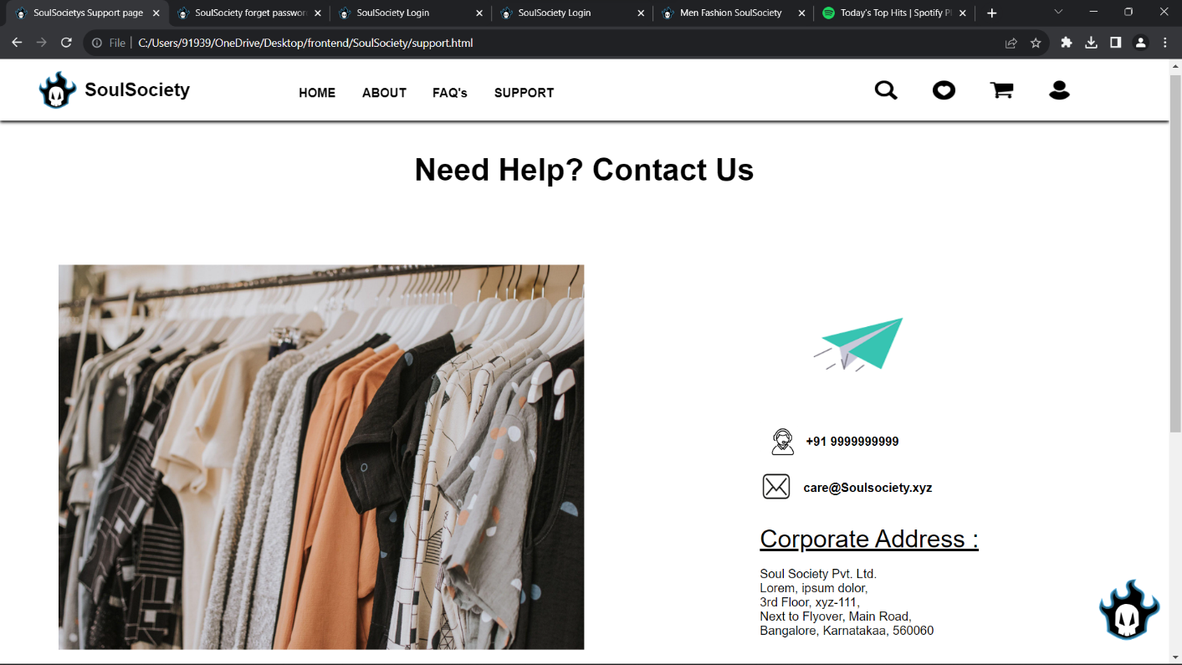

**SupportPage-ScreenShot:1**

**Conclusion :**

our online shopping website, meticulously crafted using HTML and CSS, stands as a testament to the ever-evolving landscape of retail in the digital age. As we reflect on the journey through this virtual marketplace, it's clear that the synergy between technology and design has revolutionized the way we shop.

With the power of HTML and CSS, we've built a platform that not only offers a vast selection of products but also prioritizes user-friendliness, security, and responsiveness. We understand that convenience, accessibility, and trust are paramount to your shopping experience, and we are committed to delivering on these fronts.

As we move forward, our dedication remains unwavering. We will continue to adapt, innovate, and enhance our website to meet the evolving needs of our valued customers. Your feedback and suggestions are invaluable to us as we strive to provide you with the best online shopping experience possible.

In this dynamic realm of e-commerce, we invite you to embark on a journey of exploration, convenience, and endless possibilities. Join us in shaping the future of retail and enjoy the ease and excitement of shopping from the comfort of your own space.